**Req# - CI002**

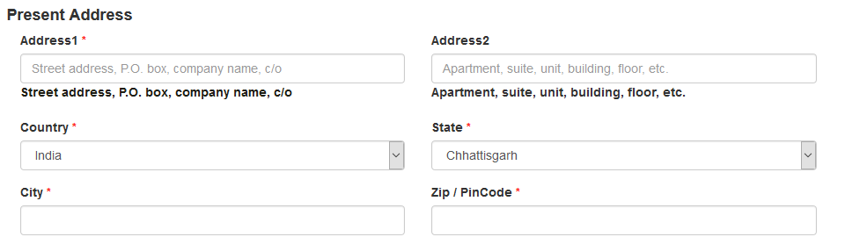

Names of Union Territories like Delhi, Chandigarh, Dadra & Nagar Haveli, Daman & Diu, Lakshadweep, Pondicherry are missing in Present address, Permanent Address and Previous Addresses